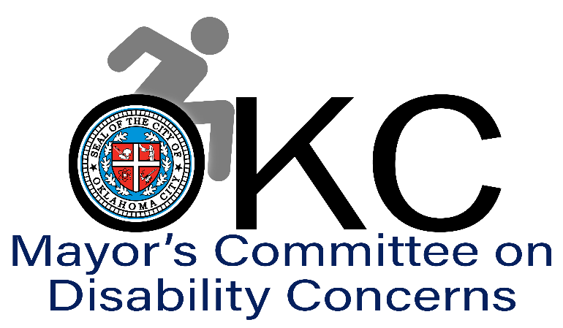
2024 Meeting Schedule. 2nd Wednesday of every month at 9 a.m. at OKC Central Maintenance Facility Training Center, 3738 SW 15th St., Bldg. 3, Oklahoma City, OK 73108
9 a.m., January 10, 2024
9 a.m., February 14, 2024
9 a.m., March 13, 2024
9 a.m., April 10, 2024
9 a.m., May 8, 2024
9 a.m., June 12, 2024
9 a.m., July 10, 2024
9 a.m., August 14, 2024
9 a.m., September 11, 204
9 a.m., October 9, 2024
9 a.m., November 13, 2024
9 a.m., December 11, 2024

